ENERGY BAND THEORY: CONDUCTORS, SEMICONDUCTORS AND INSULATORS
2-1Conductors
The term conductor is applied to any material that will support a generous flow of charge when a voltage source of limited magnitude is applied across its terminals.
Copper is a good conductor. The reason is its atomic structure (Fig.2-1). The nucleus of the atom contains 29 protons (positive charges). When a copper atom has a neutral charge, 29 electrons (negative charges) circle the nucleus. The electrons travel in distinct orbits (also called shells). There are 2 electrons in the first orbit, 8 electrons in the second, 18 in the third, and 1 in the outer orbit.
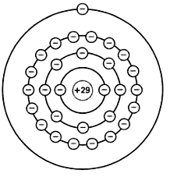
Figure 2-1 Copper atom
Stable Orbits
The positive nucleus of Fig. 2-2 attracts the planetary electrons. The reason why these electrons are not pulled into the nucleus is the centrifugal (outward) force created by their circular motion. This centrifugal force is exactly equal to the inward pull of the nucleus, so that the orbit is stable.
In a larger orbit, an electron travels more slowly, producing less centrifugal force. So the larger the orbit of an electron, the smaller the attraction of the nucleus. The outermost electron in Fig. 2-1 travels very slowly and feels almost no attraction to the nucleus.

The Core
In electronics, all that matters is the outer orbit which is known as Valence orbit. The orbit controls the electrical properties of the atom. To emphasize the importance of the valence orbit, we define the core of an atom as the nucleus and all the inner orbits. For a copper atom, the core is the nucleus (+29), and the first three orbits (-28).
The core of a copper atom contains 29 protons and 28 inner electrons so it has a net charge of +1. Fig. 2-2 shows the core and the valence orbit, where the valence electron is in a large orbit around a core and has a net charge of only +1. Because of this, the inward pull felt by the valence electron is very small.
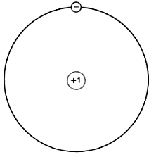
Figure 2-2Core diagram of Copper atom
Free Electron
Since the attraction between the core and the valence electron is very weak, an outside force can easily dislodge this electron from the copper atom. This is why valence electrons are known as free electrons and copper is a good conductor. The slightest voltage causes the free electrons to flow from one atom to the next. The best conductors are copper, silver and gold.
Example 2-1
Suppose an outside force removes the valence elctron from a copper atom. What is the net charge of the copper atom? What is the net charge if an outside electron moves into the valence orbit of the copper atom?
Solution:
When the valence electron leaves, the net charge of the atom becomes +1. Whenever an atom loses one of its electrons, it becomes positively charged. A positively charged atom is known as a positive ion.
When an outside electron moves into the valence orbit of the copper atom, the net charge of the atom becomes -1. Whenever an atom has an extra electron in its valence orbit, it becomes negatively charged. A negatively charged atom is known as a negative ion.
2-2 Semiconductors
The best conductors have one valence electron, whereas the best insulators have eight valence electrons. A semiconductor is an element with electrical properties between those of a conductor and those of an insulator. The examples of semiconductor are Germanium (Ge) and Silicon (Si).
Germanium
Germanium is an example of a semiconductor. It has four electrons in the valence orbit. Many years ago, germanium was the only material suitable for making semiconductor devices. But these germanium devices had a fatal flaw (their excessive reverse current) that engineers could not overcome. Eventually, another semiconductor named silicon became practical and made germanium obsolete in most electronic applications.
Silicon
Next to oxygen, silicon is the most abundant element on the earth. Now silicon is the most popular semiconductor. Without it, modern electronics, communications and computers would be impossible.
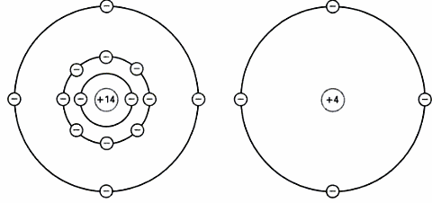
(a) (b)
Figure 2-3(a) Silicon atom (b) Core diagram
An isolated silicon atom has 14 protons and 14 electrons, as shown in Fig. 2-3a, the first orbit contains 2 electrons and the second orbit contains 8 electrons. The four remaining electrons are in the valence orbit. In Fig. 2-3b, the core has a net charge of +4 because it contains 14 protons in the nucleus and 10 electrons in the first two orbits.
Fig.2-3b shows the core diagram of a silicon atom. The 4 valence electron tell us that silicon is a semiconductor.
Another common semiconductor element is carbon(C), which is used mainly in the production of resistors.
Example 2-2
What is the net charge of the silicon atom if it loses one of its valence electrons? If it gains an extra electron in the valence orbit?
Solution:
If the silicon atom loses an electron, it becomes a positive ion with a charge of +1. If it gains an extra electron, it becomes a negative ion with a charge of -1.
Silicon Crystals
When silicon atoms combine to form a solid, they arrange themselves into an orderly pattern called a crystal. Each silicon atom shares its electrons with four neighbouring atoms in such a way as to have eight electrons in its valence orbit. Fig. 2-4a shows a central atom with four neighbours. The shaded circles represent the silicon cores. Although the central atom originally had four electrons in its valence orbit, it now has eight.
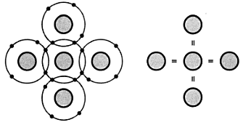
- (b)
Figure 2-4 (a) Atom in crystal has four neighbours (b) Covalent bonds
Covalent Bonds
When each neighbouring atom shares an electron with the central atom, the central atom has four additional electrons, giving it a total of eight electrons in the valence orbit. The electrons no longer belong to any single atom. Each central atom and its neighbours share the electrons and it is true for all the other silicon atoms that means every atom inside a silicon crystal has four neighbours.
In Fig. 2.4a, each core has a charge of +4. The central core and the one to its right attract the pair of electrons between them with equal and opposite force. This pulling in opposite directions is what holds the silicon atoms together.
In Fig. 2-4a, each shared electron is being pulled in opposite direction, the electron becomes a bond between the opposite cores, which is known as covalent bond. Fig 2-4b is a simpler way to show the concept of the covalent bonds. In a silicon crystal, these are billions of silicon atoms, each with eight valence electrons. These valence electrons are the covalent bonds that hold the crystal together- that give it solidity.
Valence Saturation
In a silicon crystal each atom has eight electrons in its valence orbit. These eight electrons produce a chemical stability that results in a solid piece of silicon material. The outer orbit of all elements has a predisposition toward having eight electrons. When eight electrons do not exist naturally in an element, the element has a tendency to combine and share electrons with other atoms so as to have eight electrons in the outer orbit.
When the valence orbit has eight electrons, it is saturated because no more electrons can fit into this orbit. Stated as a law:
Valence Saturation: n = 8
In words, the valence orbit can hold no more than eight electrons. The eight valence electrons are called bound electrons because they are tightly held by the atoms. Because of these bound electrons, a silicon crystal is almost a perfect insulator at room temperature, approximately 25ºC.

The Hole
When the ambient temperature (temperature of surrounding air) is above absolute zero (-273 ºC), the heat energy in this air causes the atom in a silicon crystal to vibrate. The higher the ambient temperature, the stronger the mechanical vibrations become. In silicon crystal, the vibrations of the atoms can occasionally dislodge an electron from the valence orbit. Then the released electron gains enough energy to go into a larger orbit, as shown in Fig. 2-5a, and there the electron is a free electron.
The departure of the electron creates a vacancy in the valence orbit called a hole.(see Fig2-5a). This hole behaves like a positive charge because the loss of electron produces a positive ion. The hole will attract and capture any electron in the immediate vicinity. The existence of holes enables semiconductors to do all kind of things that are impossible with conductors.
At room temperature, thermal energy produces only a few holes and free electrons. To increase the number of holes and free electrons, it is necessary to dope the crystal.
Recombination and Lifetime
In a pure silicon crystal, thermal energy creates an equal number of free electrons and holes. The free electrons move randomly throughout the crystal. Occasionally, a free electron will approach a hole, feel its attraction, and fall into it. Recombination is the merging of a free electron and a hole as shown in Fig. 2-5b.
The amount of time between the creation and disappearance of a free electron is called the lifetime. It varies from a few nanoseconds to several microseconds, depending on how perfect the crystal in the other factors.
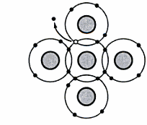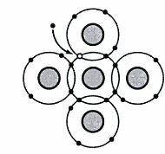
- (b)
Figure 2-5 (a) Thermal energy produces electron and hole (b) Recombination of free electron and hole
Main Ideas
At any instant, the following is taking place inside a silicon crystal:
- Some free electrons and holes are being created by thermal energy.
- Other free electrons and holes are recombining.
- Some free electrons and holes exist temporarily, awaiting recombination.

Example 2-3
If a pure silicon crystal has 1 million free electrons inside it, how many holes does it have/ What happens to the number of free electrons and holes if the ambient temperature increases?

Solution When heat energy creates free electrons, it automatically creates a hole at the same time. Therefore, a pure silicon crystal always has the same number of holes and free electrons. If there are 1 million free electrons, there are 1 million holes.

A higher temperature increases the vibrations at the atomic level, which means that more free electrons and holes are created. But no matter what the temperature is, a pure silicon crystal has the same number of free electrons and holes.
Energy Levels
In the isolated atomic structure there are discrete (individual) energy levels associated with each orbiting electron as shown in Fig. 2-6.
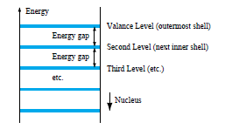
Figure 2-6 Discrete levels in isolated atomic structures
Higher Energy in larger Orbit
Electrons in the smallest orbit are on the first energy level; electrons in the second orbit are on the second energy level; and so on. The more distant the electron from the nucleus, the higher the energy state. Since an electron is attracted by the nucleus, extra energy is needed to lift an electron into a larger orbit. Some of the external forces that can lift an electron to higher energy levels are heat, light, and voltage.
Energy Bands
In the energy band theory of conductor, semiconductor and insulator we have three different bands of energy-
- Valence Band: In this energy band there are large no of free electrons available. Filling of the valence band can be partial or complete. These bands never get empty.
The major disadvantage of the electrons present in this band is that these electrons are unable to attain energy from any external source of electric field.
- Conduction band: The density of the electrons is very few. As compared to the electrons present in the valence energy bands, these electrons can gain energy from the external field of electric field.
- Forbidden Band: Electrons are absent in this energy band. Some little amount of energy is needed for electron shifting to conduction band from valence band. This type of gap is known as band gap. Symbol used to represent band gap is E_{g}.

Conductor
In a conductor, the valence band is partially filled, and since there are numerous empty levels, the electrons are free to move under the influence of an electric field. The conductor has electrons in the conduction band even at 0 K. In a conductor there is no forbidden energy gap between valence and conduction band as shown in Fig. 2-7a.
.
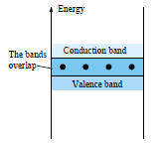
Figure 2-7 (a) Energy bands of Conductor

Insulator

In an insulator, electrons completely fill the valence band; and the gap between it and the next band, which is the conduction band is large (typically 5 eV or more) as shown in Fig.2-7b. The electrons cannot move under the influence of an electric field unless they are given enough energy to cross the large energy gap to the conduction band.
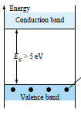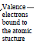
Figure 2-7 (b) Energy bands of Insulator

Semiconductor
Semiconductors have relatively narrow forbidden gaps which can be crossed by an electron having an energy of roughly one electron volt. At 0 K or absolute zero(-273.15ºC), all the valence electrons of semiconductor materials find themselves locked in their outermost shell of the atom with energy levels associated with the valence band as shown in Fig. 2-7c. However, at room temperature (300 K, 25 ºC) a large number of valence electrons have acquired sufficient energy to leave the valence band, cross the energy gap defined by E_{g} and enter the conduction band.
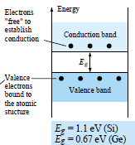
Figure 2-7 (c) Energy bands of Semiconductor
Majority and Minority, Doping
2. 2 Doping a Semiconductor
Doping is a way to increase conductivity of a semiconductor. It is the process of adding impurity atoms to an intrinsic crystal to alter its electrical conductivity. A doped semiconductor is called an extrinsic semiconductor.
Increasing the Free Electrons
In order to dope a silicon crystal it is first melted. By this the covalent bonds will be broken and the silicon will change from solid to liquid. To increase the number of free electrons ,pentavalent atoms ,which have 5 electrons in the valence orbit, are added to the molten silicon. Examples of pentavalent atoms include arsenic, antimony and phosphorus. As these materials donate an extra electron to the silicon crystal they are referred to as donor impurities. Figure 2.2.1 shows how doped silicon crystal appears after it cools down and re-forms its solid crystal structure.
Figure 2.2.1
It is clear that a pentavalent atom is in the center surrounded by four silicon atoms. Since each pentavalent atom has five valence electrons, the neighbouring atoms share an electron with the central atom and an extra electron is left over which remains in the larger orbit. It is the free electron.
Each pentavalent or donor atom in a silicon crystal produces one free electron. The manufacturer controls the conductivity of a doped semiconductor in this manner. The more the impurity that is added, the greater the conductivity. Thus a semiconductor may be lightly or heavily doped. A lightly doped semiconductor has a high resistance whereas a heavily doped semiconductor has a low resistance.
Increasing the Number of Holes
The number of holes in a semiconductor can be increased by doping silicon crystal using trivalent impurity,one whose atoms have only three valence electrons.Eg: Aluminium, Boron, Gallium.
Figure 2.2.2 shows a trivalent atom in the center. It is surrounded by four silicon atoms, each sharing one of its valence electrons.
Figure 2.2.2

Since the trivalent atom originally had only three valence electrons and each neighbour shares one electron ,only seven electrons are in the valence orbit.This means that a hole exists in the valence orbit of each trivalent atom.A trivalent atom is also called an acceptor atom because each hole it contributes can accept a free electron during recombination.
Two Types of Extrinsic Semiconductors
A semiconductor can be doped to have an excess of free electrons or an excess of holes.Because of this there are two types of doped semiconductors.
n-Type Semiconductor
Silicon which is doped with pentavalent impurity is called an n-type semiconductor, where n stands for negative. Figure 2.2.3 shows an n-type semiconductor. Since the free electrons outnumber the holes in an n-type semiconductor the free electrons are called the majority carriers and the holes are called the minority carriers.
Figure 2.2.3
Because of the applied voltage ,the free electrons move to the left and the holes move to the right. When a hole arrives at the right end of the crystal, one of the free electrons from the external circuit enters the semiconductor and recombines with the hole.The free electrons shown in fig 3 flow to the left end of the crystal ,where they enter the wire and flow on to the positive terminal of the battery.

p-Type Semiconductor
Silicon that has been doped with a trivalent impurity is called a p-type semiconductor, where p stands for positive. Figure 2.2.4 shows a p-type semiconductor. Since holes outnumber free electrons, the holes are referred to as the majority carriers and the free electrons are known as the minority carriers.
Figure 2.2.4
Because of the applied voltage the free electrons move to the left and the holes move to the right.In fig 4 the holes arriving at the right end of the crystal will recombine with free electrons from the external circuit.
There is also a flow of minority carriers in fig 4.The free electrons inside the semiconductor flow from right to left. Because there are very few minority carriers ,they have almost no effect in the circuit.

- A doped semiconductor has 10 billion silicon atoms and 5 million trivalent atoms. If the ambient temperature is 25˚C, how many free electrons and holes are there inside the semiconductor? Each trivalent atom contributes one free hole. So the semiconductor has 5 million free holes produced by doping. There will be no almost no electrons by comparison because the only electrons in the semiconductor are those produced by heat energy.
- If an n-type semiconductor is to be produced, which of these is to be used?
(a) Acceptor atoms (b) Donor atoms (c) Pentavalent impurity (d)Silicon
Ans : Donor atoms
- Electrons are the minority carriers in which type of semiconductor ?
Ans: p-type
- What are the differences between n-type and p-type semiconductors ?
Ans:
- An n-type semiconductor has electrons as the majority carriers and holes as minority carriers.
- A p-type semiconductor has holes as the majority carriers and electrons as minority carriers.
- Differentiate between majority and minority carriers.
Ans: In an n-type semiconductor the free electrons outnumber the holes.The
free electrons are called the majority carriers and the holes are called the
minority carriers.
In a p-type semiconductor since holes outnumber free electrons,the holes
are referred to as the majority carriers and the free electrons are known as the
minority carriers.
- In equally doped extrinsic semiconductors n-type has larger conductivity than
p-type semiconductor? Why?
Ans: Electrons are the majority carriers in n-type semiconductors and mobility
of electrons is more than that of holes at a given doping level. This results in
increased conductivity of n-type semiconductors.

The Unbiased Diode
Trivalent atom:
Each trivalent atom in a doped silicon crystal produces one hole as shown in a piece of p type semiconductor. The minus sign in the circle is the trivalent atom and the plus sign is the hole in its valence orbit.
Figure: P type Semiconductor
Pentavalent atom:
Each pentavalent atom in a doped silicon crystal produces one electron as shown in a piece of n type semiconductor. The plus sign in the circle is the pentavalent atom and the minus sign is the electron in its valence orbit. A semiconductor material is electrically neutral because the number of pluses and minuses are equal.
Figure: N type Semiconductor
Pn crystal or junction diode:
A single crystal with p-type material on one side and n-type material on other side with the junction is known as junction diode.
Figure: PN Junction
Ions:
Due to the repulsion nature of p type and n type, the free electrons on the n side tends to diffuse across the junction. When a free electron enters the p region it becomes a minority carrier and has a short lifetime and recombines with a hole. Then the hole disappears and the free electron becomes a valence electron.
Each time an electron diffuses across a junction it creates a pair of ions i.e. positive ion and negative ion as shown in the fig.
Figure: Creation of Ions at junction
Here the circled plus signs are the positive ions and the circled minus signs are the negative ions. The ions are fixed in the crystal structure because of covalent bonding and they cannot move around like free electrons and holes.
The depletion layer:
Each pair of positive and negative ions at the junction is called a dipole. As the number of dipoles builds up the region near the junction is an charge empty region known as depletion region.
Figure: Depletion layer
Barrier Potential:
Each dipole has an electric field between the positive and negative ions. If additional free electrons enter the depletion region, the electric field tries to push them back to n region and the strength of the electric field increases until equilibrium is reached. Hence this field is equal to the difference of potential called the barrier potential. It is 0.3V for Ge diodes and 0.7V for Si diodes.
Forward Bias
The dc source is connected across a diode. The negative terminal is connected to the n-type material and the positive terminal is connected to the p-type material known as forward bias as shown in the fig.
Figure: Forward Bias
If the battery voltage is less than the potential barrier, the battery pushes holes and free electrons towards the junction, the free electrons will not have sufficient energy to deplete through the junction. Suppose they enter the depletion layer the ions will push them back to n region. Hence there is no current flow through the diode.
If the battery voltage is greater than the potential barrier, the battery pushes holes and free electrons towards the junction, the free electrons will have sufficient energy to deplete through the junction and recombine with the holes.Hence there is a continuous current flow through the diode.
Now consider a single electron through the entire circuit. Once the free electron leaves the negative terminal of the battery, it enters the right end of the diode and travels through the n-region until it reaches the junction. When the battery voltage is greater than 0.7V, the free electron has enough energy to deplete through the junction, enters the p region and recombines with the hole. Now this free electron becomes a valence electron. This valence electron travels towards left end of the diode and a new hole appears and the process continuous. The purpose of the series resistor is to limit the amount of forward current.
Reverse Bias
Figure: Reverse Bias
Reverse the battery source as shown in the fig, now the negative terminal is connected to the p side and the positive terminal to the n side known as reverse bias. The negative battery terminal attracts the holes and the positive battery terminal attracts the free electrons, the holes and free electrons flow away from the junction and depletion layer widens.
Figure: (a) Depletion Layer (b) Widening of Depletion Layer
When the holes and electrons move away from the junction, the newly created ions increase the potential difference across the depletion region. The wider the depletion region the greater is the potential difference. The depletion region stops growing when the potential difference is equal to the applied reverse voltage and the electrons and holes stop moving away from the junction. As the reverse voltage increases, the depletion layer gets wider.
Minority-Carrier Current
A small current exists with the reverse bias due to the thermal energy that continuously creating pairs of free electrons and holes.
Figure: Reverse Minority Saturation Current
Assume that thermal energy has created a free electron and hole near the junction. The depletion layer pushes the free electron to the right forcing one electron to leave the right end of the crystal. The hole in the depletion region is pushed to the left. This extra hole on the p side lets one electron enter the left end of the crystal and fall into the hole. Thermal energy is continuously producing electron hole pairs inside the depletion region and small continuous current flows in the external circuit. The reverse current caused by thermally produced minority carriers is called saturation current and denoted by Is. As the reverse voltage increases the number of thermally created minority carriers will not increase.
Problems
1. Is the diode shown in the circuit forward or reverse biased?
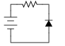
Solution: This diode is reverse biased
2. The arrow direction in the diode symbol indicates
a) Direction of electron flow.
b) Direction of hole flow (Direction of conventional current)
c) Opposite to the direction of hole flow
d) None of the above
Solution: b

3. The knee voltage (cut in voltage) of Si diode is:
a) 0.2 V b) 0.7 V c) 0.8 V d) 1.0 V
Solution: b
4. When the diode is forward biased, it is equivalent to
a) An off switch b) An On switch c) A high resistance d) None of the above
Solution: b
.
**********
Barrier Potential and Temperature
The junction temperature is the temperature inside a diode at the pn junction. The barrier potential depends on the junction temperature. An increase in junction temperature creates more free electrons and holes in the doped regions. As these charges diffuse into the depletion layer, it becomes narrower. Less barrier potential at higher junction temp$e$rature.
The barrier potential of a si diode decreases by 2mV for each degree Celsius rise. The ambient temperature is the temperature of the air that surrounds the diode. When the diode is conducting the junction temperature is higher than the ambient temperature due to the heat created by recombination.
Reverse – Biased diode
Transient Current
When the reverse voltage increases, holes and electrons move away from the junction. As the free electrons and holes move away from the junction positive and negative ions are left behind and the width of the depletion region increases. The current flows in the external circuit known as transient current and drops to zero once the depletion layer stops growing.
Reverse Saturation Current
The thermal energy creates a hole and free electron inside the depletion layer . The free electron at A and the hole at B contributes to reverse current. Because of the reverse bias, the free electron move towards the right and hole towards the left end. The higher the junction temperature the greater the saturation current. I_{s} doubles for every 10 ⁰ C rise in temperature.
Figure: Thermal energy
Silicon versus Germanium
In a silicon atom the distance between the valence band and the conduction band is called the energy gap. When thermal energy produces free electrons and holes it gives valence electrons enough energy to jump into the conduction band. The larger the energy gap, more difficult for the thermal energy to produce electron hole pairs. Si has more energy gap.
In a germanium atom the valence band is much closer to the conduction band. Ge has smaller energy gap than Si. It produces more electron hole pairs resulting in excessive reverse current.
Problems
1) Reverse saturation current in a Silicon PN junction diode nearly doubles for every
a) 2º rise in temp
b) 5º rise in temp
c) 6º rise in temp
d) 10º rise in temp
Solution: d

2) A forward potential of 10V is applied to a Si diode. A resistance of 1 KΩ is also in series with the diode. The current is
a)10 mA b) 9.3 mA c)0.7 mA d) 0
Solution: b

3. When a reverse bias is applied to a diode, it will
a) Raise the potential barrier
b) Lower the potential barrier
c) Increases the majority-carrier current greatly
d) None of these
Solution: a

4. Under normal reverse bias voltage applied to diode, the reverse current in Si diode
a) 100 mA b) order of μA c) 1000 μA d)None of these
Solution: b

3. Diode Theory
3.1 Introduction:
An ordinary resistor is a linear device because of the graph of its current versus voltage is a straight line. A diode is a nonlinear device because the graph of its current versus voltage is not a straight line because of barrier potential.
When, Diode Voltage < Barrier Potential then Diode Current is small.
When, Diode Voltage > Barrier Potential then Diode Current increases rapidly.
3.2 Schematic Symbol:
The schematic symbol for a diode is shown in Fig. 1. The p side is called the anode and the n side is called the cathode. The diode symbol looks like an arrow that point from the p side to the n side, from anode to the cathode.
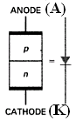
Fig. 1 Diode Schematic Symbol
3.3 Basic Diode Circuit:
A diode circuit is shown in Fig.2. In this circuit, the diode is forward biased, because the positive battery terminal drives the p side through a resistor and a negative battery terminal is connected to the n side. With this the circuit is trying to push holes and free electrons toward the junction.
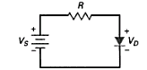
Fig. 2 Diode circuit – Forward Bias.
In complicated circuit, to decide whether the diode is forward biased or not, check that the external circuit is pushing current in the easy direction of flow or not. Is yes, the diode is forward biased. The easy direction is the same direction as the diode arrow or opposite to the electron flow.
In complicated circuit, we can also use Thevenin’s Theorem to determine whether it is forward biased.

3.4 Diode Curve:
The diode curve is shown in Fig. 3. When the diode is forward biased, there is no significant current until the diode voltage is greater than barrier potential. When the diode is reverse biased, there is almost no reverse current until the diode voltage reaches the breakdown voltage. Then, avalanche produces a large reverse current, destroying the diode.
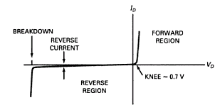
Fig. 3 Diode Curve
In the forward region, the voltage at which the current starts to increase rapidly is called the kneevoltage of the diode. The knee voltage equals the barrier potential. If the diode voltage is more than the knee voltage, the diode conducts easily. If the diode voltage is less than the knee voltage, the diode conducts poorly. The knee voltage of a Silicon diode is given by,
Vk ≈ 0.7 V Equation (1)
The knee voltage of a Germanium diode is given by Vk ≈ 0.3 V.
Above the knee voltage, the diode current increases rapidly. This means that small increases in the diode voltage cause large increases in diode current. After the barrier potential is overcome, all that impedes the current is the ohmic resistance of the p and n regions. The sum of the ohmic resistances is called the bulk resistance of the diode. It is defined as,
R_{B} = R_{P} + R_{N} Equation (2)
The bulk resistance depends on the size and the doping concentration of the p and n regions. Often, R_{B}< 1 Ω.
If the current in a diode is too large, the excessive heat can destroy the diode. For this reason, a manufacturer’s data sheet specifies the maximum current a diode can safely handle without shortening its life or degrading its characteristics.
The maximum forward current is one of the maximum ratings given on a data sheet. This current may be listed as I_{max}, I_{F(max)}, I_{O} etc. depending upon the manufacturer. e.g. A 1N456 has a maximum forward current rating of 135 mA. This means that it can safely handle a continuous forward current of 135 mA.
The power dissipation of a diode is given by,
P_{D} = V_{D}I_{D} Equation (3)
The power rating is the maximum power the diode can safely dissipate without shortening its life or degrading its properties. It is given by,
P_{max} = V_{max}I_{max} Equation (4)
Where, V_{max} is the voltage corresponding to I_{max}. e.g. If a diode has a maximum voltage and current of 1 V and 2 A, its power rating is 2 W.
ding to I_{max}. e.g. If a diode has a maximum voltage and current of 1 V and 2 A, its power rating is 2 W.
3.5 Approximations of a Diode:
We need approximations because exact analysis is very tedious and time consuming in most situations. There are three approximations of a diode as mentioned below.
- First Approximation or Ideal Diode
- Second Approximation
- Third Approximation
Sl. No. | First Approximation or Ideal Diode | Second Approximation | Third Approximation
1 | Usually adequate for trouble shooting. | Gives quick and easy solutions in many cases. | Used for better accuracy.
2 | Ideally a diode acts like a perfect conductor (zero resistance) when forward biased and like a perfect insulator (infinite resistance) when reverse biased. | The graph says that no current exists until 0.7 V appears across the diode. At this point, the diode turns on. Therefore, only 0.7 V can appear across the diode, no matter what the current. | We include the bulk resistance R_{B}. The effect of R_{B} on diode curve is shown in the graph. After the silicon diode turns on, the voltage increases linearly with an increase in current. The greater the current, the larger the diode voltage because of the voltage drop across the bulk resistance.
3 | Current Voltage graph of an Ideal diode.  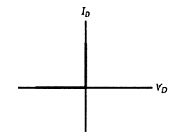 | Current Voltage graph of Second approximation diode.  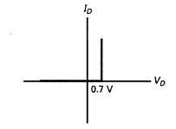 | Current Voltage graph of Third approximation diode.  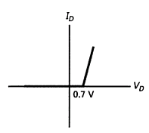
4 | Equivalent symbol  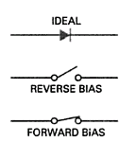 | Equivalent symbol  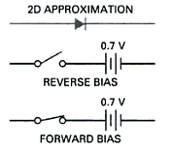 | Equivalent symbol  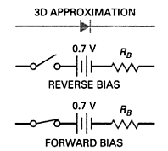
5 | An ordinary switch has zero resistance when closed and infinite resistance when open. Therefore, an ideal diode acts like a switch that closes when forward biased and opens when reverse biased. | If the Thevenin voltage facing the diode is > 0.7 V, the switch will close. When conducting, then the diode voltage is 0.7 V for any forward current. If the Thevenin voltage is less than 0.7 V, the switch will open and there is no current through the diode. | The equivalent circuit for the third approximation is a switch in series with a barrier potential of 0.7 V and a resistance of R_{B}. When the diode voltage is larger than 0.7 V, the diode conducts.
6 | V_{D} = 0 V | V_{D} = 0.7 V | V_{D} = 0.7 V + I_{D}R_{B}  Where, I_{D} is the diode current.
7 |  |  | Often, R_{B}< 1 Ω, so can safely be ignored in calculations. To ignore bulk resistance, the guideline is:  R_{B}< 0.01R_{TH}  Where, R_{TH} is the Thevenin resistance facing the diode. The error is less than 1%, if the condition is satisfied.
8 | Diode Power P_{D} = V_{D} I_{D} = 0 V | Diode Power P_{D} = V_{D} I_{D} | Diode Power P_{D} = V_{D} I_{D}
Note: For Germanium Diode, 0.7 V needs to be replaced by 0.3 V.
Example 3-1
Consider the circuit shown in Fig. 3.1. Assume diodes are ideal.
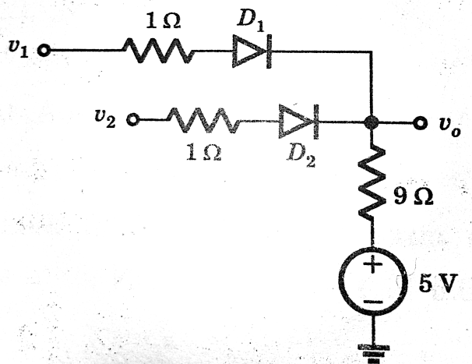
Fig. 3.1
- Find the output voltage v₀ if v₁ = v₂ = 10 V.
- Find the output voltage v₀ if v₁ = -5 V and v₂ = 10 V.

Solution. a) Assume both D₁ and D₂ ON,
v₀ = $\frac{\frac{10}{1}+ \frac{10}{1}+\frac{5}{9}}{\frac{1}{1}+ \frac{1}{1}+ \frac{1}{9}}$= 9.737 V.
Check assumption:
i_{D1} = i_{D2=} $\frac{v1-vo}{1}$ = 10 – 9.737 = 0.263 mA > 0,
So both D₁ and D₂ are in the ON state.
b) Assume D₁ OFF and D₂ ON,
v₀ = $\frac{\frac{10}{1}+\frac{5}{9}}{\frac{1}{1}+ \frac{1}{9}}$= 9.5 V.
Check assumption:
i_{D2=} $\frac{v1-vo}{1}$ = 10 – 9.5 = 0.5 mA > 0, Therefore D₂ ON,
v_{D1} = v₁ – v₀= - 5 – 9.5 = - 14.5 V < 0, Therefore D₁ OFF

Example 3-2
The 1N4001 of Fig. 3.2 (a) has a bulk resistance of 0.23 Ω and a load resistance of 15 Ω. What is the load voltage, load current, and diode power? Repeat the same for a load resistance of 2 kΩ.
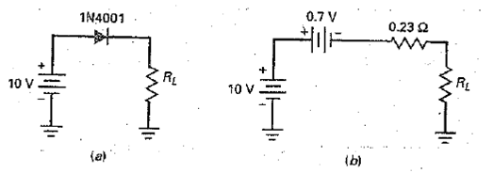
Fig. 3.2
Solution. Now the total resistance is:
R_{T} = 0.23 Ω + 15 Ω = 15.23 Ω
The total voltage across R_{T} is: V_{T} = 10 V – 0.7 V = 9.3 V.
Therefore, the load current is: I_{L =} $\frac{9.3 V}{15.23 Ω}$ = 0.611 A
The load voltage is: V_{L} = (0.611 A)(10 Ω) = 6.11 V.
Now for R_{L} = 2kΩ, the bulk resistance is small enough to ignore because it is less than 1/100 of the load resistance. In this case, we can use the second approximation to solve the problem.
Since the diode voltage is 0.7 V, the load current is:
I_{L =} $\frac{10 V-0.7 V}{2 kΩ}$ = 4.65 mA
The load voltage is: V_{L} = (4.65mA) (1 kΩ) = 4.65 V
And the diode power is: P_{D} = (0.7 V)(4.65 mA) = 3.26 mW.
Example 3-3
Find the voltage v₀ and the current i_{D1} for the circuit in Fig. 3.3. Use diode second approximation.
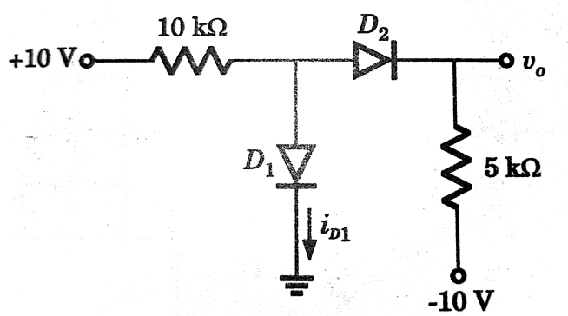
Fig. 3.3

Solution.
D₂ is ON. The current through D₂ is
i ₌ $\frac{10-0.7-(-10)}{15 k}=1.287 mA$
The voltage across D₁ is
- v₁ = 10 – 10(1.287) = -2.867 V, Thus D₁ is OFF.
- i_{D1} = 0, v₀ = 5ki – 10 = -3.57 V

Example 3-4
For the circuit in Fig. 3.4, at what condition of v_{S} will both the diodes be ON. Use Second approximation.
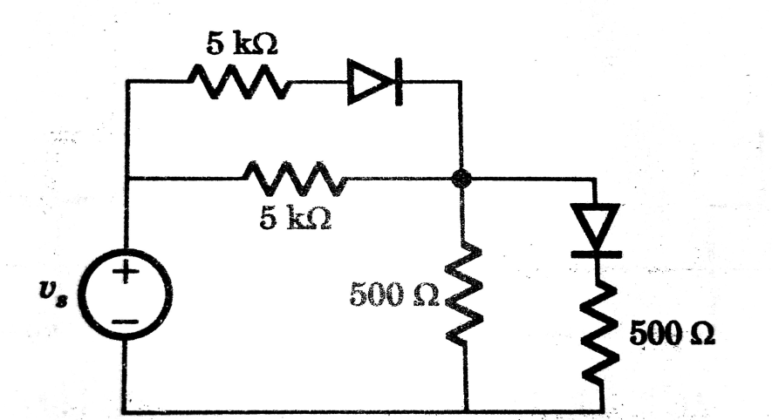
Fig. 3.4
Solution.
For v_{s} small, both diodes are OFF. For v_{s}> 0.7 V, D₁ is ON. For v₁> 0.7 V (Fig. 3.4.1), both diodes will be ON,

$$\frac{vs-0.7-v1}{5}+ \frac{vs-v1}{5} = \frac{v1}{0.5}+ \frac{v1-0.7}{0.5}$$

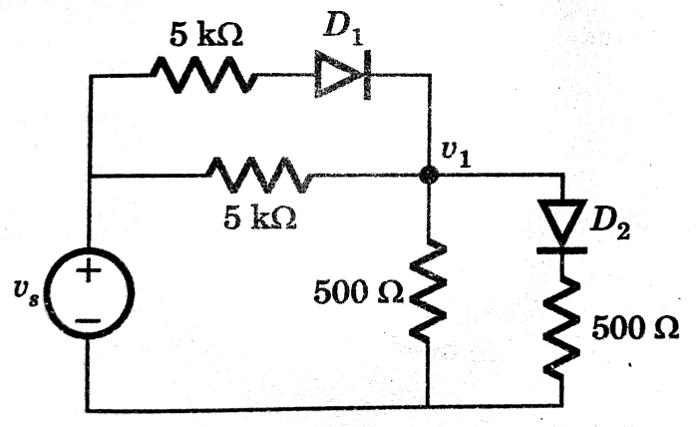
Fig. 3.4.1
v₁ ₌ $\frac{2vs+6.3}{22}$>0.7V , So v_{s}> 4.55 V
3.7 Calculation of Bulk Resistance
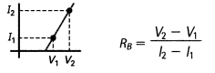
Equation (5) where, V₁ and I₁ are the voltage and current at some point at or above the knee voltage; V₂ and I₂ are the voltage and current at some higher point on the diode curve.
The bulk resistance equals the inverse of the slope above the knee. The greater the slope of the diode curve, the smaller the bulk resistance.
3.8 Calculation of DC resistance of a diode
The dc resistance of a diode is the ratio of total diode voltage to total diode current. In the forward direction, the dc resistance is symbolized by R_{F} and in reverse direction it is designated as R_{R}.
R_{F} = $\frac{ForwardVoltage}{ForwardCurrent}$Equation (6)
Forward resistance is low compared to the reverse resistance.
R_{R} = $\frac{ReverseVoltage}{ReverseCurrent}$Equation (7)
Dc resistance decreases as we approach the breakdown voltage.
The dc resistance of a diode is different from bulk resistance. The dc resistance is the total resistance. Bulk resistance is the resistance of only p and n regions.
DC Resistance of a diode = Bulk resistance + the effect of the barrier potential. Equation (8)
DC Resistance of a diode > Bulk resistance

Example 3-5
Here are some diodes and their worst-case specifications:

Diode | I_{F} | I_{R}
1N914 | 15 mA at 1.5 V | 37.5 nA at 30 V
1N4001 | 1.9 A at 2.1 V | 12 µA at 60 V
1N1185 | 10.5 A at 1 V | 6.9 mA at 150V

Calculate the forward and the reverse resistance for each of these diodes.
Solution.Forward Resistances
R_{F} = $\frac{1.5 V}{15 mA}$ = 100 Ω for 1N914
R_{F =} $\frac{1.1 V}{1 A}$= 1.1 Ω for 1N4001
R_{F =} $\frac{1 V}{10.5 A}$= 0.095 Ω for 1N1185
Notice how the dc resistance decreases as the current increases.
Reverse Resistances
R_{R =} $\frac{30 V}{37.5 nA}$= 800 MΩ for 1N914
R_{R =} $\frac{50 V}{10 µA}$= 5 MΩ for 1N4001
R_{R =} $\frac{150 V}{6.9 mA}$= 21.7 kΩ for 1N1185
Example 3-6
The data sheet of 1N4001 (silicon diode) gives a forward voltage of 0.81 V for a current of 1 A. Calculate the bulk resistance

Solution.Since this is a silicon diode, it has a knee voltage of approximately 0.7 V and a current of approximately zero.
Therefore R_{B =} $\frac{V2-V1}{I2-I1}$ = $\frac{0.81 V-0.7 V}{1 A-0 A}$ = 0.11Ω

3.9 Load Lines
A load line is a tool used to find the exact value of diode current and voltage. The Q point is the point of intersection of load line and a diode curve. It represents a simultaneous solution between the diode curve and load line. The Q point coordinates on the graph are the actual diode current and voltage. Q is an abbreviation for Quiescent which means at rest. Use the following steps to find the Q point.
Step 1: The circuit to find the load line equation is shown in Fig.5.

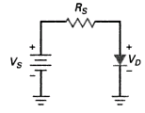
Fig. 5. Load Line Analysis
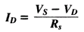 Equation (9)
Step 2: Find the value of I_{D} with given V_{S} and R_{S} when V_{D} = 0 V.
This gives Saturation Point (I_{D} = maximum current, V_{D} = 0 V) =>First Point
Step 3: The cut-off point is the point which represents the minimum current. When V_{D} = V_{S}, we get I_{D} = 0 A.
Cut-off Point (I_{D} = 0, V_{D} = V_{S}) =>Second Point
Step 4: Because equation (9) is linear, all the points will lie on the straight line shown in Fig. 6. The straight line is called Load Line. Join the Saturation Point and Cutoff Point to get a Load Line. The point of intersection of this load line with diode curve is a Q Point. Read the coordinates of the Q Point from the graph to get diode current and voltage. From graph shown in Fig.6, we get the diode current of 12.5 mA and diode voltage of 0.75 V.
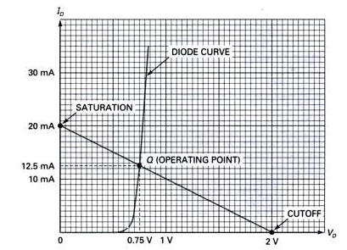
Fig. 6 Q Point is the Intersection of the diode curve and the Load Line.

